MODFLOW Modeling ModelMuse
Nov 19, 2010
Creating, Running, and Displaying Results of a Simple MODFLOW Model 1
Formulas and Functions 8
Spatial Variability 8
Observations 10
Troubleshooting Exercises 18
Answers 20

Creating, Running, and Displaying Results of a Simple MODFLOW Model
The purpose of this exercise is to introduce some of the basic features of ModelMuse. We will create a simple model with a single well, run the model and display the results.
- Start ModelMuse by double-clicking on its icon.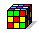
- Choose to create a new MODFLOW model and click Next. 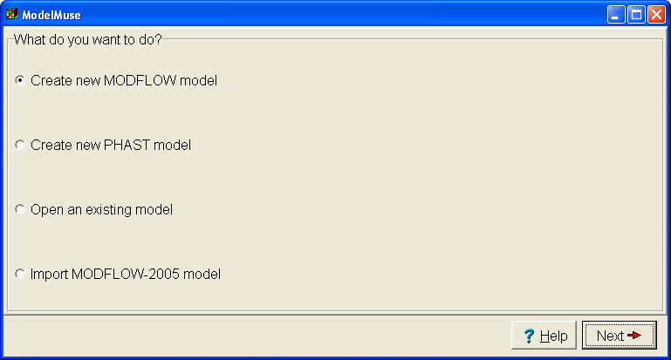
- Change the number of columns and rows each to 100 and the number of layers to 1. Change the name of the single layer group to “Aquifer” and set its bottom elevation to -100. Then click Finish. 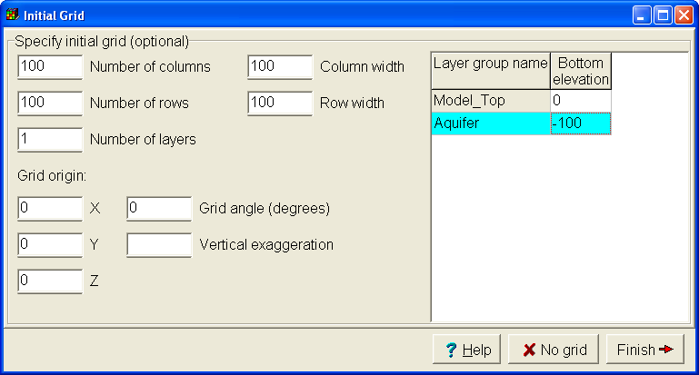
- Select Navigation|Pan and hold the mouse over the grid. Then drag with the mouse. The grid should move with the mouse. Note that there is a toolbar button with the same image as the image in the menu. Any menu item with an image has a matching tool bar button.
- Hold the mouse over the grid and roll the scroll wheel on the mouse, the model should zoom in and out.
- Click the Undo Position button repeatedly until you get back to the original view or just click the Restore Default 2D View button.
- The MODFLOW Packages and Programs dialog box is where you activate any of the optional packages in MODFLOW that you want to use. The packages are listed in a tree control on the left. To activate a package check the checkbox or radio-button next to its name. Then set any other options for the package in the part of the dialog box to the right of the tree control. This model will use the Well package. Select Model|MODFLOW Packages and Programs… and check the check box for the Well package. Then click OK.
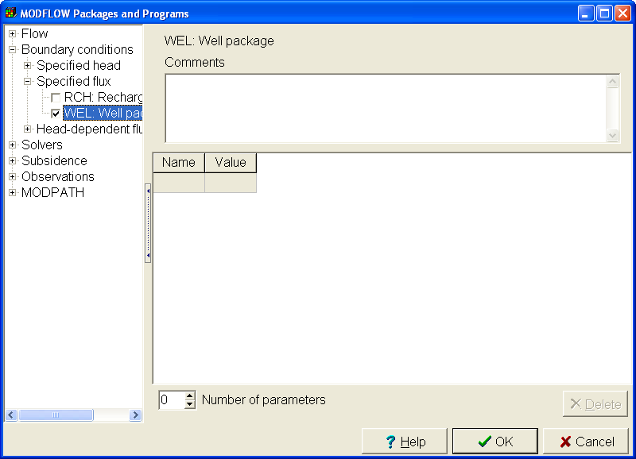
The MODFLOW Options dialog box is used to turn on the “wetting”, change the model units and select some other options.
- Select Model|MODFLOW Options…, switch to the Options tab, change the time unit to “days”, and click OK. (Don’t turn on the wetting option.)
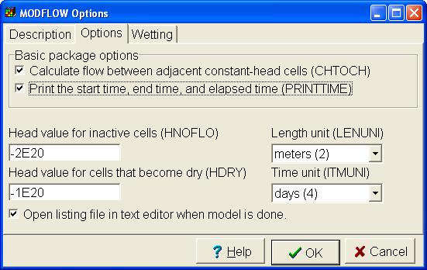
- The MODFLOW Time dialog box is where you set up the stress periods for the model. Select Model|MODFLOW Time… Change the Starting time to 0, the Ending time to 1000, the length of the first time step to 10 and change from a steady-state to transient stress period. Then click OK.
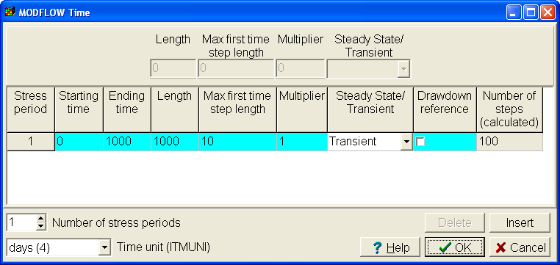
- The aquifer properties, layer elevations and other similar data are specified by data sets. For now, we will assume that all the aquifer properties are uniform and that the layer is flat. Select “Data|Edit Data Sets...” Then select the Kx data set under “Required|Hydrology” and change its default formula to 0.1.
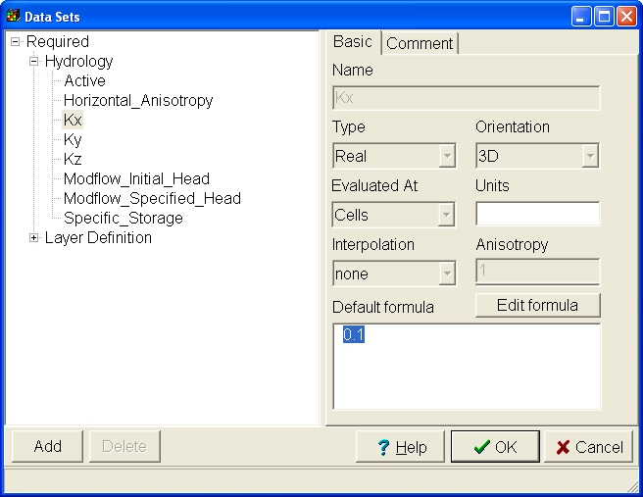
- Objects are used to specify the locations of things like wells, rivers, and drains. They can are also used to set up spatially vary properties of data sets. In this case, we will use an object to define a well. Select Object|Create|Point and then click in the center of the grid. The Object Properties dialog box will appear. Switch to the MODFLOW Features tab. Enter a starting time of 0, and ending time of 1000 and a pumping rate of -100. Then click OK.
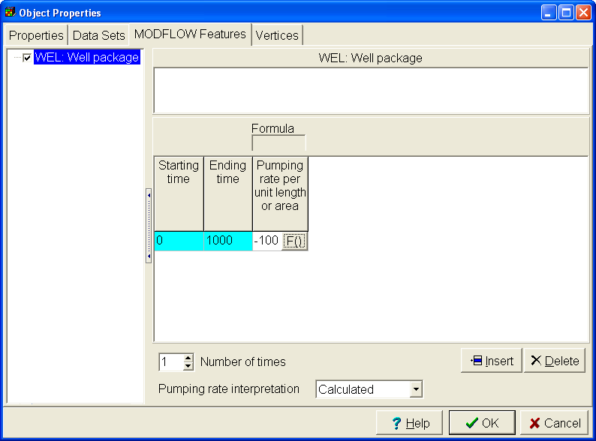
- Select File|Save select a file name such as “Exercise1” and save the file. If you are prompted to create an archive, answer “yes”.
- Select File|Export|MODFLOW Input Files, select a file name and click Save. ModelMuse will create the MODFLOW input files and start running MODFLOW. The progress of the model will be monitored in ModelMonitor. ModelMonitor will display any error or warning messages and graph the percent discrepancy in the budget. If the percent discrepancy is larger than 1%, there is probably a problem with the model. (However, smaller percent discrepancies do not guarantee that the model is OK.) Close ModelMonitor when the model is done running. The listing file will be opened in Notepad when you close ModelMonitor. You can close the listing file. There will also be a command line window that you can close.
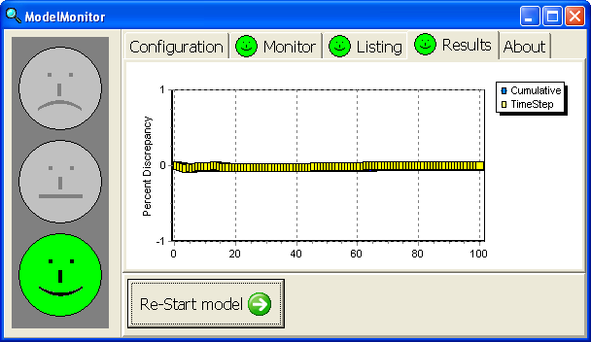
- Select File|Import|Model Results… An Open File dialog box should appear. The file containing the heads should already be selected by default so just click Open. In the Select Model Results to Import dialog box, the data for the last time step should already be selected so just click OK.
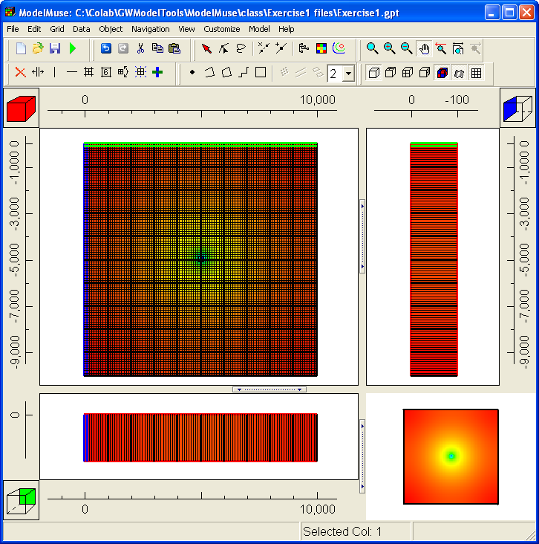
- Select “Data|Show Grid Values”. Move the cursor over the model grid and observe the value displayed in the dialog box. This is one way to see what the data value is at a particular location.
- Select Data|Display Data Set Values. Select Data Sets|Optional|Model Results|3D Data|Head_P1_S100. Click the Copy button. Open Excel and paste into Excel. If you want to transfer the data to another program, this is one way to do it.
- Start GW_Chart and change the Chart Type to Hydrographs. Change the column and row to 50 and then click the Read button. Select the file with heads for this exercise. GW_Chart can plot the change in head vs time.
- Start Model Viewer. Select File|New and set the model type to a MODFLOW 2000/2005 model. Select the name file for the model and click OK. Accept the defaults for the data selection. Select Show|Solid. Then select Toolbox|Animation and click Run. Try dragging with the mouse to rotate the view of the model. Model Viewer can be used to get a higher quality 3D display of the model results.

Formulas and Functions
The purpose of this exercise is to introduce you to the use of formulas in ModelMuse. It will illustrate how you can use a formula to link data sets to one another along with the usage of functions and global variables.
- Open the model from Exercise 1 and save it again with a new name such as Exercise2. (Use File|Save As... to save the file with a different name.)
Formulas can be used to link to data sets as well as to global variables. To illustrate this, we’ll use a formula to set the bottom of the layer to top of the layer minus a constant.
- Select “Data|Edit Data Sets…”
- Expand “Required|Layer Definition” and select the “Aquifer Bottom” data set.
- The default formula is -100. Click the “Edit formula” button to open the Formula Editor.
- On the right expand “Data Sets|Required|Layer Definition” and double-click on the Model_Top data set. In the edit window in the middle of the left side of the dialog box, change the formula to Model_Top – 80.
- Before closing the Formula Editor, expand the “Functions|Grid”. Then click one of the grid functions and click the “Function Help…” This will display the help for the selected function.
- ModelMuse has undo and redo buttons . After closing the Formula Editor and the Data sets dialog box, Try clicking them and checking the elevation of the lower layer to see if it changed.

Spatial Variability
The following exercise will first show how to define spatial variability without using parameters. Another exercise after that will show how it is done using parameters.
- Start a new model and use the default grid.
- Change the selected layer to layer 1 if layer 1 is not already the selected layer.
- Select Object|Create|Polygon.
- Click on the top view of the model to start drawing a polygon. Have the polygon surround part of the grid. When you are finished, double-click and the Object Properties dialog box will appear.
- Switch to the Data Sets tab.
- Expand “Required|Hydrology” and check the check box for the Kx data set.
- Change the formula for Kx to 2E-5 and then click OK to close the dialog box.
- Select Data|Color Grid”, select the Kx data set and click Apply.
- Select Data|Show Grid Values and move the cursor over the grid to see what the different colors represent.
- Locate the cube with the red square that indicates the selected layer. 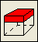 Click on the cube below the red square to change the selected layer to layer 2. 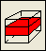 Did the object you drew before affect Kx on layer 2?
- Draw another polygon and use this one to set Kx inside the polygon to 3E-5. Did this polygon affect the values of Kx in layer 2? Did it affect the values of Kx on layer 1?
- Select “Object|Select Objects” and click on one of the objects that sets the value of Kx to select that object. Click on the object again but hold the mouse down and drag the object to a new position. How did moving the object affect Kx?
- Double click on one of the second object that sets the value of Kx to open the “Object Properties” dialog box. Change the formulas for the Higher Z-coordinate and Lower Z-coordinate so that they are “Model_Top” and “Middle_Aquifer_Bottom” respectively. Click OK to close the dialog box. How does this change affect Kx?
- Drag one of the objects that sets the value of Kx so that it overlaps with the other object. What is the value of Kx in the area of overlap?
- Select the second of the two objects that sets the value of Kx data set. Then right-click and select “To Back”. How does this affect the value of Kx in the area of overlap between the two objects?
- Try drawing a polygon on the front or side views of the model, Can you use this object to set Kx values?

Observations
In this example, we will use Observations process in MODFLOW to define head observations and river observations. We will also import data from Shapefiles to define the layer boundaries.
- Start a new model with 20 rows 20 columns, and 3 layers. Make the rows and columns 5,000 feet wide. (You don't need to change the layer elevations now.)
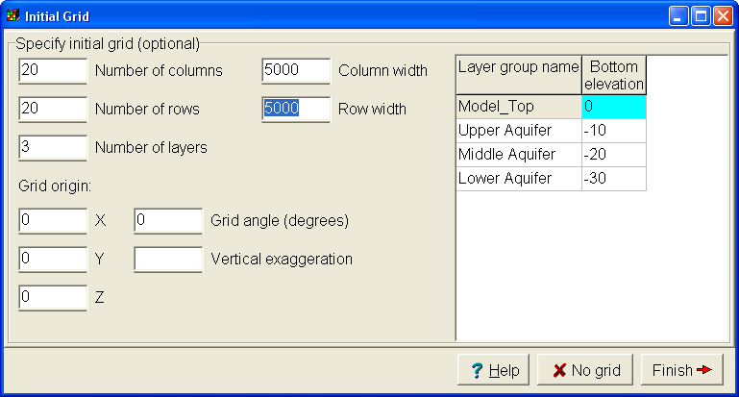
Next we will import the layer elevations from shape files.
- Select File|Import|Shapefile and select Top.shp.
- Check Set values of cells by interpolation.
- On the Data tab, check the check box for the TOP attribute, change the Data Set to Model_Top, and change the interpolation method to Triangle Interp. Then click OK.
- Repeat steps 2-4 with the Shapefiles Bottom1.shp, Bottom2.shp and Bottom3.shp. Use them to set the bottoms of the upper, middle, and lower aquifer respectively. Then select Object|Show-or Hide Objects and check the check box for "All Objects" to hide all the objects.
- (Optional) Select "View|Vertical Exaggeration", click the "Default" button and click OK.
- (Optional) Double-click on the ruler above the top view of the model and enter 1E5 as the sample number. Change the precision from 5 to 6 and click OK. This will change the appearance of the number on the ruler.
At this point, the elevations of the layers have been defined. The next step is to define the layer types
- Select Model|MODFLOW Layer Groups...
- Select the Upper Aquifer and change its layer type to Convertible
- Select the Middle Aquifer and change its layer type to Non-simulated and click OK.
Next we define the model units
- Select "Model|MODFLOW Options..." and change the length unit to feet and the time units to days. Then click OK.
Now we define some parameters in the LPF package. The first parameter will define the hydraulic conductivity in the left half of the top layer. The second parameter will define the hydraulic conductivity in the right half of the top layer. The third parameter will define the hydraulic conductivity in the bottom layer
- Select "Model|MODFLOW Packages and Programs..." The LPF package is active by default. In it change the number of HK parameters to 3. Set to values of the parameters to 10,000, 20,000, and 40,000 respectively. Check the check box for Use Zone for all three parameters and then click OK.
- Make sure that layer 1 is the active layer and draw a polygon around the left half of the model. On the Data Sets tab of the Object Properties dialog box, expand Required|HK Parameter and check the check box for HK_Par1_Zone. Then set the formula to True and close the dialog box.
- Draw another object on the right half of the model and use it to set HK_Par2 Zone to true.
- Change the active layer to layer 3 and draw an object completely surrounding the grid. Use it to set the value of HK_Par3 Zone to true.
- Try coloring the grid (Data|Color Grid) with the Kx data set. ModelMuse will use a formula that reproduces how MODFLOW assigns values to cells. Try moving one of the objects that set the zones for HK_Par1 and HK_Par1 overlap. What is the hydraulic conductivity where the zones overlap? (You can use the undo button to move the objects back to their original locations afterwards.)
- Next select (Model|MODFLOW Time...) and set up the stress periods as shown below.
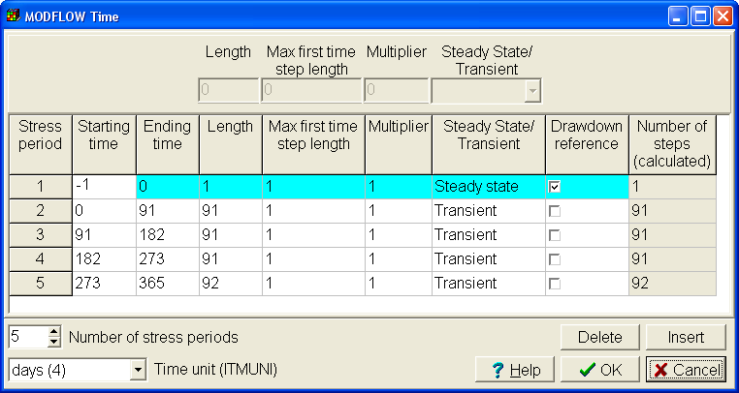
This model will also use the recharge package and define a recharge parameter.
- Select "Model|MODFLOW Packages and Programs..." Expand Boundary conditions|Specified flux and check the check box for the Recharge package. Change the number of parameters to 1 and set the value of the parameter to 1. Leave the Recharge Location option set to Top layer. Click OK to close the dialog box.
- Draw an object that completely surrounds the grid. In the Object Properties dialog box, check the checkbox for the Recharge package on the MODFLOW Features tab and check the check box for the recharge parameter (RCH_Par1). This will cause a new column to appear in which you specify the recharge rate multiplier for that parameter. Fill in the rate multipliers as shown below. Then click OK to close the Object Properties dialog box.
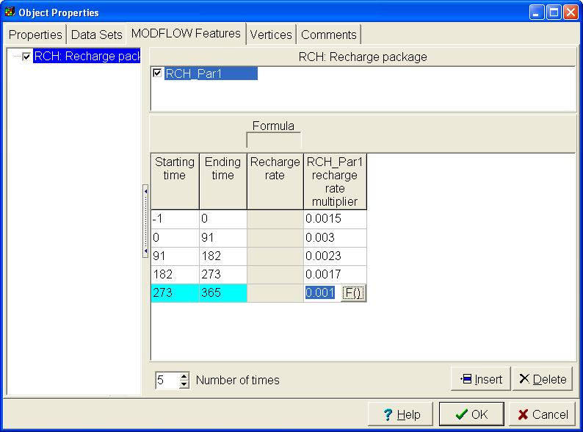
In this model, all the water leaves through a river. We will now define the river.
- Select "Model|MODFLOW Packages and Programs..." Expand Boundary conditions|Head-dependent flux and check the check box for the River package. Then click OK to close the Object Properties dialog box.
In order to help see where the river should be located, we will contour the top of the model and then draw the river down the middle of the valley.
- Select "Data|Contour Data..." and select the Model_Top data set. Then make the top layer the active layer draw an object as shown below.
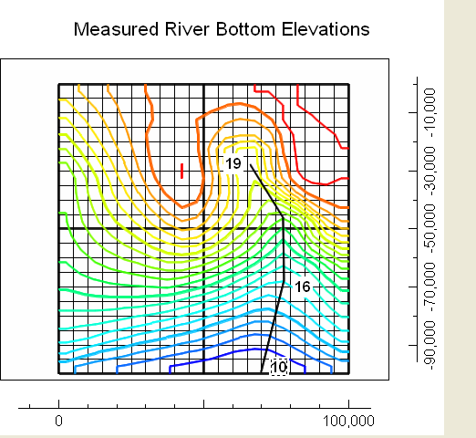
- The river elevation varies along the length of the river. We will assign elevations to certain points along the river and then interpolate the elevation among the points.
- Select "Object|Edit|Vertex Values" and double click on the vertex at the upstream end of the river. In the Vertex Values dialog box enter "River Bottom" as the key and 19 as the value. Then click OK. Note that the symbol for the vertex has changed from a square to a diamond.
- Double click on the vertex at the downstream end of the river. In the Vertex Values dialog box enter "River Bottom" is already defined as a key. Enter 10 as the value for that key. Then click OK.
- Double click on the next to last vertex in the figure above. In the Vertex Values dialog box enter "River Bottom" is already defined as a key. Enter 16 as the value for that key. Then click OK.
At this point we have defined the river elevations but we need to do one more thing to apply them to the river.
- Select the Arrow button and double click on the object that defines the river to open it in the Object Properties dialog box.
- On the MODFLOW Features tab, check the check box for the River package and enter -1 as the Starting time, 365 as the ending time and 80 as the conductance per unit length.
- Click in the cell in the table where River bottom is defined. Instead of entering a number, we will enter a formula. Click on the F() button that appears in the table to open the Formula Editor.
- In the list on the right, expand Functions|Object and double click on InterpolatedVertexValue. The formula will appear on the left with "Key" selected. Replace Key with "River Bottom". Be sure to include the quotation marks around "River Bottom". The final formula should be InterpolatedVertexValue("River Bottom"). Click OK to close the Formula editor.
- The river stage is one foot above the river bottom Use the formula editor to change to formula for it to InterpolatedVertexValue("River Bottom") + 1. Close the formula editor and the Object Properties dialog box.
- To verify that the river stage has been assigned correctly, color the grid with the river stage.
We still have a few more things we need to do before running the model. First set the initial head.
- Select "Data|Edit Data Sets...", Expand "Required|Hydrology" and select Modflow_Initial_Head. Change the formula to 40 and click OK.
- Select "Model|MODFLOW Packages and Programs...", expand "Solvers" and select the PCG package. Change both HCLOSE and RCLOSE to 0.01.
Color the grid with Kz. Note that in the middle confining layer, Kz is zero and that the formula used to define Kz is Kx/10. That needs to be fixed. We could use another object to define Kz but in this case, we'll just adjust how Kx is defined.
- Select "Object|Show or Hide Objects", expand "Data Sets|Required|HK Parameter|HK_Par3_Zone" and double click on the object listed there. This opens the object in the Object Properties dialog box. This object sets the zone for HK_Par3 to be the bottom layer. Change the formula for the Higher Z coordinate to "Upper_Aquifer_Bottom" so that the object applies to both the middle and lower layers. Click OK to close the dialog box. Now Kz for the middle layer should be 4000.
- To check that you've done everything correctly, try running the model now and then import the model results. The model should run to completion and the final imported heads should look reasonable.
ModelMuse has a hidden interface for ModelMate. To facilitate using this model with ModelMate, we will unlock the ModelMate interface.
- Select "Help|About". Then right-click on the USGS logo and make sure the check box for "Enable ModelMate Interface" is checked.
The next thing to do is to define some observations.
- Select "Model|MODFLOW Packages and Programs..." and expand "Observations". Check the check boxes for the Head Observation and River Observation packages. Then click OK.
- The Manage Flow Observations dialog box appears. Select the river observation package and click the Add button. Change the number of times to 1. Enter 365 for the time, -3648900 for the Observed value, 1000000 for the statistic and Standard dev. (1) for the statistic. Then click OK. (The negative sign of the river observation means that the water is leaving the aquifer and entering the river.)
- Select "Object|Show or Hide Objects", expand "MODFLOW Features|River package" and double click on the object listed there to open it in the Object Properties dialog box. On the MODFLOW Features tab, select the river observation package and check the check box for the Rvob1 observation group. You can leave Factor blank for now.
- The observation doesn't apply to the whole object. If it did, we would just set Factor to 1. Instead, we will create a new data set that will have a value of 1 where the river cells are part of the river observation and 0 everywhere else.
- Select "Data|Edit Data Sets..." and click the Add button. Change the name of the new data set to RivObFactor. Then click the OK button.
- Now draw a polygon that surrounds the portion of the river object that extends from the upstream end down through the next to last vertex as illustrated below. In the Object Properties dialog box, go to the Data Sets tab and expand User Defined. Check the check box for RivObFactor and set the formula to 1. Click OK.
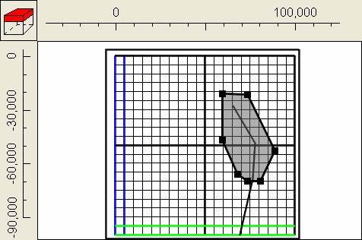
- Now double-click on the object that defines the river and go back to the River observation on the MODFLOW Features tab. Change the factor to RivObFactor. Now only those cells for which RivObFactor will be part of the observation.
- Next make sure layer 1 is the active layer and create four point objects as illustrated below. They will define the head observations. They all defines observations at time = 365, with a standard deviation of 1. The observed heads at each point are shown next to each object.
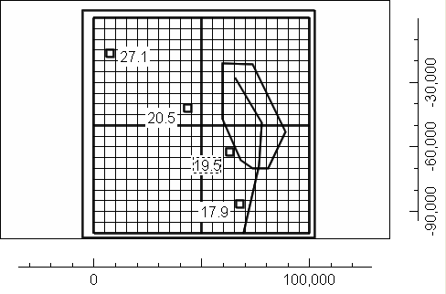
- You can now run the model. At the end of the listing file, you can check and see how well the observations matched the simulated values.

Troubleshooting Exercises
Open the ModelMuse help and refer to the “Troubleshooting” section when answering the following questions.

Problem 1
Open the model named Problem1.gpt. Note that the Well package is active and that there is an object that is supposed to define a well. However, if you color the grid with the well pumping rate, no wells are colored. Why is that?

Problem 2
Open the model named Problem2.gpt. Note that the Well package is active and that there is an object that is supposed to define a well. However, if you color the grid with the well pumping rate, no wells are colored. Why is that?

Problem 3
Open the model named Problem3.gpt. Color the grid with the Kx data set. Note that there are 4 objects that are supposed to each set a different value of Kx. Why do the Kx values all appear to be the same?

Problem 4
Open the model named Problem4.gpt. Color the grid with the Kx data set. Note that there are 4 objects that are supposed to each set a different value of Kx. Why are all the Kx values the same?

Problem 5
Open the model named Problem5.gpt. Color the grid with the Kx data set. The single object in this model is supposed to set the values of Kx for every cell in the grid. However, in the middle layer, Kx is set by the default formula. Why is that and what can you do about it?

Problem 6
Open the model named Problem6.gpt. Color the grid with the Kx data set. Note that the object is supposed to set Kx for all the cells it encloses but there is a group of cells inside it whose values are set by the default formula. Why is that?

Problem 7
Open the model named Problem7.gpt. Note that the Well package is active and that there is an object that is supposed to define a well. However, if you color the grid with the well pumping rate, no wells are colored. Why is that?

Problem 8
Open the model named Problem8.gpt. Note that the Well package is active and that there is an object that is supposed to define a well. However, if you color the grid with the well pumping rate, no wells are colored. Why is that?

Problem 9
Open the model named Problem9.gpt. Color the grid with the Kx data set. There are two objects in this model that are supposed to set the value of Kx. However, only one of them appears to have an effect. Why is that and what can you do about it?

Problem 10
Open the model named Problem10.gpt. Color the grid with the Kx data set. This model uses three parameters to define the distribution of Kx. Each parameter uses a zone array. The parameters have values of 0.0001, 0.0002 and 0.0003. However, the calculated values of Kx are 0.0001, 0.0003 and 0.0005. Why is that and what can you do about it?

Answers

Problem 1
In the object, the Z coordinate is set to “Model_Top + 1.” which is above the top of the model.
The Grid Value dialog box can help with diagnosing this problem. If you display it and check the check box to display the 3rd-dimension coordinate of the selected object, the Z-coordinate is always listed as “not assigned” regardless of which layer is selected. This indicates that the object does not intersect the grid.

Problem 2
The starting and ending times for the well are 0 and 1. However, the stress period ends at time zero.
When you color the grid, you will get a warning that the end of the last stress period is zero and the last defined time is 1.

Problem 3
The four objects all set the values of Kx for layer 2. The selected layer is layer 1.
The fact that all the cells were blue (instead of green) is a clue that the values are not all the same even though you don’t see any cells that aren’t blue. When everything is the same value, the color from the middle of the color scale will be used to color the cells.

Problem 4
The Grid Value dialog box can help with diagnosing this problem. The explanation says “set using parameters via the formula: 0.001”. Recall that when MODFLOW uses parameters to set the value of a data set, you can’t use objects to set the value of that data set directly. Thus, when determining the value of Kx, the 4 objects have no effect. However, you could use objects to set the values of the multiplier and zone array associated with an object.

Problem 5
In the Show or Hide Objects dialog box, note that the object is marked with the word “Intersected” instead of “Enclosed”. That means it sets the values of cells that it intersects. The edges of the object are outside the grid so they don’t intersect the middle layer. The formulas for the top and bottom of the object are “Model_Top” and “Lower_Aquifer_Bottom”. That causes the top of the object to be at the top of the grid and the bottom of the object to be at the bottom of the grid. Thus the object intersects the top and bottom layer but it doesn’t intersect the middle layer.
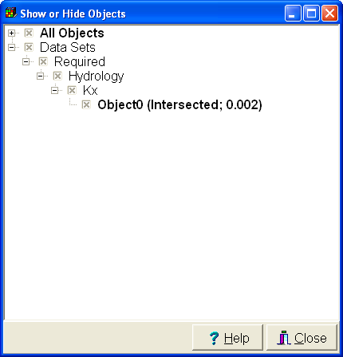

Problem 6
The Grid Value dialog box can help with diagnosing this problem. When you place the cursor over one of the cells where the object is working as it should, it says that the top of the object is at 0 and the bottom is at -10. However, In the cells where the object isn’t working right, it says that the top of the object is at -10 and the bottom is at 0. The top of the object is below the bottom of the object. For an object to enclose anything, its top must be above its bottom. When we look at the formulas for the higher and lower Z-coordinates, they are “Model_Top” and “Upper_Aquifer_Bottom”. Those seem OK so the problem must be with the Model_Top and Upper_Aquifer_Bottom data sets. Color the grid with the Model_Top data set and you will see that the area where KX isn’t set right, the elevation of Model_Top is different. When we place a cursor over this area, the Grid Value dialog box gives as an explanation “Enclosed by Object0 with formula: -10”. If we display the Show or Hide Objects dialog box, we find that Object0 is hidden. When we display and edit it, we find that it sets Model_Top and Upper_Aquifer_Bottom to -10 and 0 respectively. The front view of the model looks like this where the layers top and bottom are reversed. 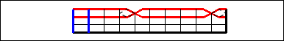

Problem 7
When you color the grid you get an error message that says “No boundary conditions assigned to the WEL: Well package because the object does not set the values of either enclosed or intersected cells.” When we double-click on the object, we see that the error message is correct.

Problem 8
The object is in layer 2. In the MODFLOW Layer Groups dialog box, you will see that layer 2 is a non-simulated layer. You can only have wells in simulated layers.

Problem 9
The Grid Value dialog box can help with diagnosing this problem. When the mouse is over a cell enclosed by the inner object, the explanation it gives for the value of Kx is “Enclosed by OuterObject with formula: 0.0003”. The Rearrange Objects dialog box lists the objects from back to front Inner_Object is listed before OuterObject so OuterObject overrides value set by Inner_Object. You can drag the rows in the Rearrange Objects dialog box to fix the problem. You drag rows by clicking on the gray area to the left of the row and dragging.

Problem 10
Recall that when parameters are used, zone arrays determine where each parameter is applied and then zone arrays further modify the value applied to an individual cell. None of these parameters use multiplier arrays so they are not an issue. The problem must be with the zone arrays. Recall that if no multiplier arrays are used, the value applied to a cell is the sum of the values of all the parameters that apply to a cell. To get the value we are getting, more than one parameter must apply to some cells. Try coloring the grid with each of the Zone arrays. HK_Par1_Zone and HK_Par2_Zone look OK but the HK_Par3_Zone and HK_Par2_Zone overlap. Object3 is used to define where HK_Par3_Zone is true and it uses the formula “If(HK_Par1_Zone, False, True)”. The formula should be If((HK_Par1_Zone OR HK_Par2_Zone), False, True). Actually, the formula could be made simpler by eliminating the If function: “NOT(HK_Par1_Zone OR HK_Par2_Zone)”

